Progress Report

Team Number: 3

Team Member Names: Kevin Munoz, Muhammad S Rehman

Name of Project: Fast New York Restaurant

Screenshot of Storyboard

Index.html by Kevin M

Menu.html by Muhammad R

About.html by Kevin M & Muhammad R

Screenshot of Wireframe

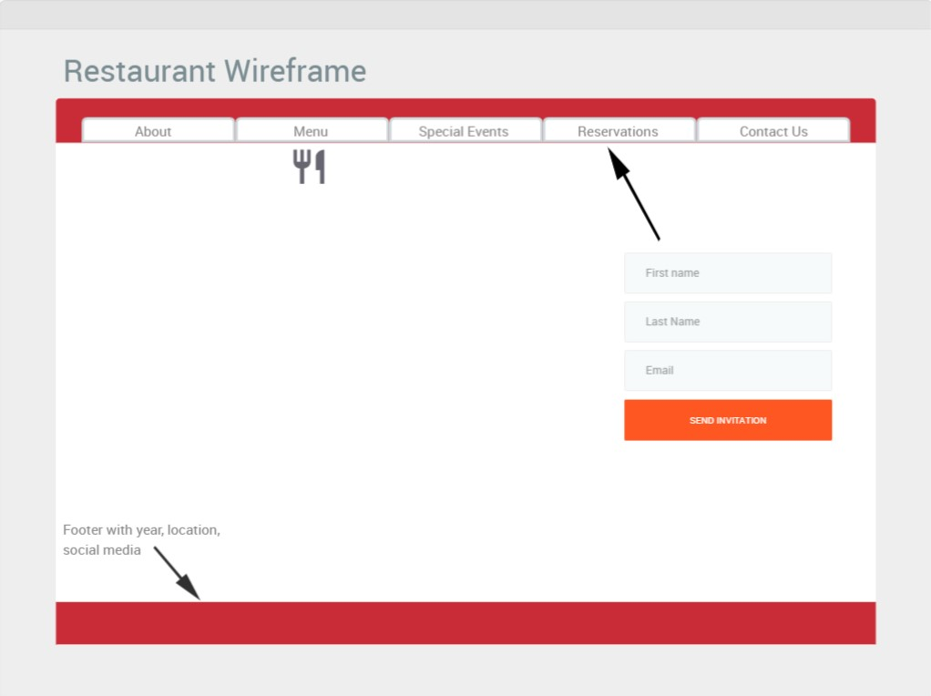

Tasks Breakdown

Home Page (index) – Kevin Munoz

Menu (menu) – Muhammad S Rehman

About Us – Kevin Munoz & Muhammad S Rehman